Larbert Village Primary School

Nursery ELC

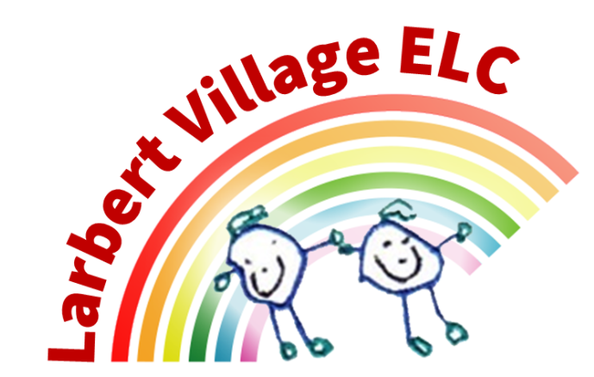

Outdoor Policy

Legislation & Research

“There is a growing body of research that shows that young children’s access to nature and outdoor play is positively associated with improved self-esteem, physical health, development of language skills and disposition to learning.” (Davy, 2009 as cited in My World Outdoors).

Recent national guidelines such as My World Outdoors (2016) and The Loose Parts Toolkit (2016) Realising The Ambition outline the importance of outdoor play to help children reach their full potential.

Objectives

We aim to:

- Use the outdoor area as a tool and a natural resource for learning.
- Include the outdoor area in our approach to learning.
- Enable children to access outdoor learning on a daily basis both morning and afternoon.
- Ensure the outdoor area offers the children the opportunity to investigate and explore, problem solve, use their imagination and creativity.
- Ensure the outdoor area offers children opportunities to develop their large and fine motor skills.
- Ensure that the children enjoy energetic activity outdoors and the feeling of well being that it brings.
- Observe, assess and record the learning that happens in the outdoor area and give children the opportunity to plan and have responsibility for their learning in the outdoor area through responsive approach to planning.
- Provide stimulation for children to understand the aspects of nature in the world and the benefits nature provides.
- Provide opportunities that develop literacy and numeracy skills in the outdoor area.
- Enable children to work on their own and with others.
- Enable children to develop an appreciation of natural beauty and a sense of wonder about the world and a desire to explore.
- Respect the outdoor environment and to care for living things.
- Enable children to manage and use the space and the freedom offered by the garden.
- Use tools safely and effectively and to follow nursery safety rules.

Method

Practitioners will:

- Facilitate access to the outdoor area at all times.
- Organise and provide necessary resources as appropriate, for example clothing, footwear, tools and report to management team when resources need replenished.
- Encourage children to use a variety of natural resources.
- Plan for weather situations e.g. rain, snow and sun.
- Involve parents in key aspects of outdoor planning.
- Organise other agencies and personnel to visit and develop the garden with children.
- Provide resources for key developmental stages.
- Ensure the safety of all children, ensuring practitioners are comfortable with their ratio of children. It is practitioner’s responsibility to ensure they are aware of how many children are in the outdoor area, and headcount as the end of session routine is implemented.

Implementation and Monitoring

The implementation of this policy is the collective responsibility of the whole staff team and in particular the individual staff member within the outdoor learning area. Monitoring will be carried out on a daily basis by the Senior Early Years Officer and further monitoring will be carried out by the SLT through observation, discussion and monitoring meetings.

Guidance Documents

- Loose Parts Toolkit
- My World Outdoors
- Realising the Ambition
- How Good is Our Early Learning and Childcare
- Early Years Outdoors
- Curriculum for Excellence

Date – November 2025
Review - November 2026

