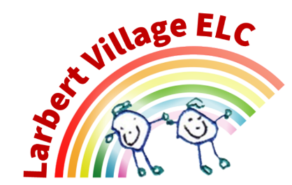

Larbert Village Primary School and Nursery ELC

Suncream Policy

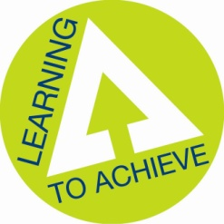

Sun Smart Policy

For the summer months our Sun Smart Policy will be in force.

Young skin is delicate and very easily damaged by the sun. All children no matter whether they tan easily or not, should be protected from the sun.
Children (like adults) with fair or red hair, pale eyes or freckles are at most risk. Keep out of direct sunlight, especially between 11.00am and 3.00pm.

- ELC will provide children with factor 50 sun protection designed for children.
- Families can send in their own suncream.
- Where possible children should come to nursery prepared for the sun. Sun cream should be applied at home and children should wear clothes to cover their shoulders i.e. T. Shirt (not strappy tops). Sun hats are strongly recommended.
- All children will have sun cream reapplied at lunch time (Children with allergies should bring their own from home).
- Children will be encouraged to play in the shade and stay hydrated with regular drink breaks
- If a child refuses suncream they will be kept indoors and the parents will be notified.

To set a good example all staff must
- Wear Sunscreen
- Make sure children play in the shade or stay indoors between 11.00am and 3.00pm
- Make sure everyone drinks lots of water
- Reinforce the Sun Smart Safety message with stories, songs and activities which should regularly be shared with families.

Updated: November 2025
Review November 2026

