Larbert Village Primary School

Nursery ELC
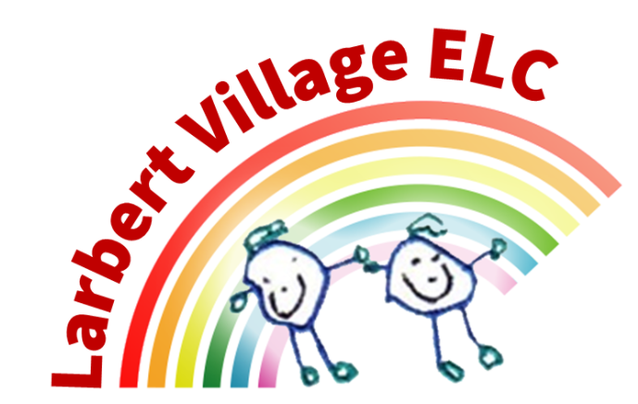

Toothbrushing Policy

Toothbrushing Policy
Based on Care Inspectorate’s “Supporting healthy smiles” practice note.
Aims
- To promote good oral hygiene habits in children and support lifelong healthy teeth and gums.
- To provide a supervised tooth‐brushing routine in the nursery, in addition to regular home brushing.
- To ensure toothbrushes and storage systems are managed safely to minimise risk of cross‐infection.
- To engage parents/carers in partnership with the nursery in promoting oral health.
Scope
This policy applies to all children aged 3–5 years attending the nursery, and all staff involved in the tooth-brushing programme.
Consent and participation
- The tooth-brushing programme is an opt out consent from parents/carers.
- Participation is voluntary. Parents/carers may opt their child out of the programme at any time by informing the nursery in writing.
- Parents/carers will be informed about the programme, including the amount and kind of fluoride toothpaste used, frequency of brushing, and storage of toothbrushes.
Frequency and timing
- Children will brush their teeth in the nursery at least once each day, as part of the routine.
- The home brushing routine (twice a day) remains essential and is encouraged.
- Timing of the session should be convenient, for example soon after snack/meal time or at another consistent point in the day, and organised to fit into the nursery’s routine.
Supervision and technique
- All tooth-brushing sessions are supervised by a member of staff. Children must not be left un-supervised while brushing.
- Children will be supported and encouraged to brush thoroughly under supervision until they are competent to brush effectively themselves.
- The adult will model and, where needed, assist brushing of children’s teeth to ensure full mouth coverage (front, back, chewing surfaces and gum line).
- Children will be encouraged to spit out excess toothpaste but not rinse with water (to maximise fluoride contact) unless otherwise advised.
- Tooth‐brushing should ideally last around 2 minutes.
Tools and materials
- Toothbrushes: Each child will have their own individual toothbrush, clearly identified (for example by name or symbol) to prevent mix-up.
- Toothpaste: A fluoride toothpaste containing at least 1000 ppm fluoride (or higher as locally recommended) will be used.
- For children aged 3–5: use a pea-sized amount of toothpaste.
- Tooth-brushes will have a small head and soft/medium bristles, suitable for young children.
- A clean plate or paper towel will be used to dispense a pa sized amount of toothpaste for each child and contamination will be avoided.
Storage and hygiene of brushes
- After brushing, each toothbrush will be rinsed under running cold water, then shaken to remove excess water and returned to its designated holder.
- Storage system: Brushes should stand upright, not touch each other, and allow air circulation to dry.
- Each child’s brush slot will be clearly labelled or matched with their symbol.
- The storage system should be located at adult height and not immediately adjacent to the brushing area to minimise contamination.
- Cleaning of the storage system, rack or individual holders: At least once a week (or more frequently if soiled) using warm water and household detergent like wash up liquid, then rinsed and dried. Disinfectant wipes are not recommended for storage systems.
- Toothbrushes that fall onto the floor or become damaged (e.g., splayed bristles) must be replaced immediately.
Staff hygiene and infection control
- Staff supervising brushing will wash their hands before and after the session and wear disposable aprons and gloves if there is a risk of contact with saliva or body fluids.
- The brushing area (sink, surfaces) will be cleaned before and after each brushing session, using appropriate detergent cleaning.
- Any broken skin on staff (cuts/abrasions) must be covered with a waterproof dressing.
Replacement of toothbrushes
- Toothbrushes will be replaced at least every term (or sooner if bristles splay, after illness, or drop onto the floor) to maintain effectiveness and hygiene.
Food, drink and timing considerations
- Ideally tooth-brushing should not be immediately after acidic food or drink; however if the programme dictates brushing at other times the benefits outweigh this concern.
- The nursery will coordinate snack and meal times accordingly and promote water or plain milk as the safest drinks for teeth.
Monitoring, record-keeping and review
- The tooth-brushing lead (named staff member) will monitor compliance with this policy and oversee audits of storage and hygiene systems.
- The policy will be reviewed annually (or more frequently if local guidance changes).
Links to external guidance
- This policy is based on the guidance issued by the Care Inspectorate’s “Supporting healthy smiles” practice note.
- Also informed by national guidance on supervised tooth-brushing schemes (UK) and early years settings.
Roles and responsibilities
- Nursery Manager: ensures the tooth-brushing programme is implemented, staff trained, materials available and policy reviewed.
- Tooth-brushing Lead: responsible for organising sessions, maintaining records, checking hygiene/storage arrangements, ordering supplies.
- Staff involved in brushing: ensure children are supervised, follow hygiene protocols, set good example, report any issues.
- Parents/Carers: support home brushing routines, give consent, inform nursery of any dental/health concerns, reinforce the habit at home.
Equality, inclusion and special needs
- All children in the 3–5 age group are included unless a parent/carer opts out.
- For children with additional support needs (e.g., sensory difficulties, swallowing concerns), the routine will be adapted as required, in consultation with parents, carers, oral-health professionals and local Childsmile staff.
- Materials and routines will be accessible and inclusive, with symbol-labelling for toothbrushes etc to support children who are pre-literate or have communication needs.
Parent/carer communications
- On enrolment and at least annually thereafter, parents/carers will receive information about the tooth-brushing programme: aims, method, toothpaste used, storage hygienic arrangements, and how they can support brushing at home.

Date – November 2025
Review – November 2026

