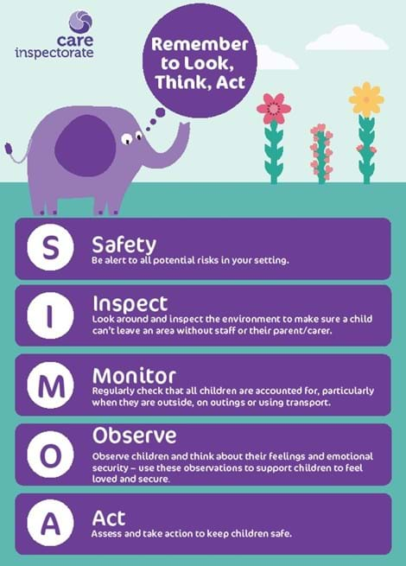

Keeping Children Safe - Look, Think, Act Campaign
Let’s keep children safe by raising awareness of how, and why, they could leave a childcare setting without a responsible adult
As we begin the new term, it’s a good time to remind all early learning and childcare services to be aware of how and why children could potentially leave a setting without staff or a parent/carer.
It is everyone’s responsibility to keep children safe, so ensure you know where your children are at all times. It is important that staff teams work well together, communicate effectively and have a shared understanding of roles and responsibilities to keep children safe. Even when busy with other activities we all need to be alert to what children are doing. It is especially important at pick up and drop off times and when outdoors or on outings. Review your procedures and identify where improvements might be needed. Review the security of your setting, are all doors, gates and perimeters secure. Most importantly are all children fully engaged in their activities and secure in their relationships with the staff. Think about how well you support all of your children to have fun and be confident in your setting.
To help you with this task, we want to introduce Simoa, the elephant, to all ELC settings. Let’s raise awareness and act responsibly to safeguard, protect and support children’s wellbeing.

Simoa always remembers:
Safe
Be alert to all potential risks in your setting.
Inspect
Look around and inspect the environment to make sure a child can’t leave an area without staff or their parent/carer.
Monitor
Regularly check that all children are accounted for particularly when they are outside, on outings or using transport.
Observe
Observe children and think about their feelings and emotional security – use these observations to support children to feel loved and secure.
Act
Assess and take action to keep children safe.
All services are required to notify the Care Inspectorate of any incidents, so that we can all share the learning and keep children safe. We want to engage with services to reduce and prevent occurrences of children being in unsafe situations.

Termly review using SIMOA
All staff involved in welcome/goodbye routine will discuss any potential risks.
Daily Welcome Routine
- Room and outside are set up and safety checks are done.
- Signing -in sheets, children’s photo’s prepared. Snack person to order lunches.
- Staff on weekly rotation is on main front door to allow children (and adult if needed) to enter the nursery. SEYO nearby if needed or parents have questions.
- All other staff in areas prepared for children arriving.
- Send register number and absences to office.
- Notes to be passed on or shared in communication book for all staff.
- Daily attendance displayed on board.
- Main door is closed between children arriving.

Daily Goodbye Routine

- All children will continue to play inside the playroom and in the top garden.
- Staff will check the cloakroom to ensure no children are out there and the internal security door will be closed. The main door will be opened to allow parents and carers to come in.
- SEYO will be on the internal security door which will be closed and locked to let parents/carers in to the nursery. Parents/carers will then go to collect their child in the playroom or garden. Staff will be in their areas and will let parents/carers know how the child has been that day and pass on any messages.
- SEYO will let the child and parent/carer out of the internal security door once they have collected their child and then sign the child out.
- Parent/carers will collect their child’s belongings from pegs/trays.
- If someone is coming to collect a child, that staff do not know, request a question to be asked and description of person. Ensure this is passed onto staff.
- If someone turns up to collect a child, that nursery personnel have not been informed about, staff will contact school office in case an emergency situation has arisen, a parent has just called or in the case where they have forgotten to inform setting of change to person collecting child. The child should not be allowed to leave until this has been clarified.

Date - August 2025
Review – August 2026

Larbert Village Primary School

Nursery ELC



Daily welcome and goodbye routine Policy

