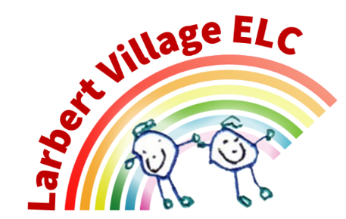

Larbert Village Primary School and Nursery ELC

Food and Nutrition Policy

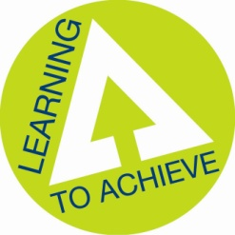

Food and Nutrition Policy for Larbert Village Nursery Class
This policy has been written with reference to Setting the Table – Nutritional guidance and food standards for early year’s childcare providers in Scotland (NHS Scotland 2015) and Food Standards Agency Scotland documentation – Cook Safe.
Our kitchen holds a Food Safety Inspection Pass Certificate from Falkirk Council's Environmental Health Department and is inspected regularly. Our Pass certificate is displayed in the kitchen.
Snack times are an important part of the service we offer and should be an enjoyable, happy and a social occasion for the children, with positive interactions shared and enjoyed. The staff are committed to offering the children healthy, nutritious and balanced snacks which meet their individual needs. The purpose of this policy is to inform parents/carers about the food provided to children, how it is prepared and the nutritional guidelines we follow.
Staff will ensure that we:
- Obtain information about any special dietary requirements, preferences and food allergies that your child has and any special health requirements, before the child starts at the setting.
- Record and act on information from you about your child's dietary needs.
- Provide separate chopping boards for children with a food allergy or a food intolerance. These boards will be stored separately from the non-allergy/intolerance boards.
- Provide a snack suitable for the dietary requirements of all children, ensuring that any food allergies/intolerances are catered for, as well as children from all cultures and religions being able to enjoy appropriate snacks. This information will be recorded and displayed for all staff in the kitchen.
- Provide information of a list of ingredients of food served regarding food allergies or intolerances.
- Plan varied menus for snacks, in consultation with all children to include different tastes, colours and textures of food.
- Make available information about the food and drinks provided for children. Please see our sample menu.
- Make sure fresh drinking water is available and accessible at all times.
- Involve children in the preparation of food. Promoting the importance of staff and children washing our hands before the preparation of food and eating.
- Provide the children with snacks and drinks that are healthy, balanced and nutritious. Full fat milk or fresh drinking water is available daily. Fruit will be available daily.
- Have a positive and welcoming eating environment to encourage children to eat well and develop good eating habits, table manners and social skills.
- Encourage the children to learn the importance of a healthy diet for good health.
- Cultural differences in eating habits and the different ways people eat their food will be respected.
- Are mindful of ways to reduce the risk of choking advice contained in Setting the Table Nutritional guidance and food standards for early years childcare providers in Scotland (NHS Scotland 2015)
- All children understand the need for tooth brushing and will participate in a daily tooth brushing programme. We have regular visits from the dental staff from the Forth Valley Health Board, to change the brushed and check documentation.

- Meet the principles laid out in the Nutritional Guidelines in Early Years. Register with the Local Authority Environmental Health Department and have completed the REHIS Elementary Food Hygiene Course. The setting is suitable for the hygienic preparation. Staff are competent to prepare and handle food.
- Are all compliant with completing checks and risk assessments relating to the preparation and storage of food.
- Notify Care Inspectorate of any food poisoning affecting two or more children looked after on the premises within 14 days.
It is important that children are given the opportunity to celebrate special occasions and cultural events, and food and drink is often used to mark these occasions. Staff will ensure that healthy options are provided.
A menu is posted on our noticeboard for you to see what your child will be eating during that particular day. This is a 2 weekly menu which is rotated each week. We celebrate festivities from other countries and cultures, so occasionally we will make a change to an item on the menu for an alternative of equal quality.
Cooking and baking simple snacks and cakes is enjoyable and instructive for children in the nursery, and we encourage this. Children themselves will sometimes participate in baking activities for example making soup, fairy cakes, fruit kebabs or pizzas. Cookery activities can incorporate practice in mathematics and health & hygiene, for example in measuring or counting ingredients and reinforcing the importance of hand washing, etc. Children also feel a sense of pride in making a snack for their peers, or taking cakes or biscuits home with them.
We accommodate a variety of diets in the nursery, for example vegetarian, vegan, lactose intolerant, various allergies, and religious specifications. Parents' comments and suggestions regarding the food we provide is always welcome.
We have a list of children's allergies and dietary requirements are posted in the nursery kitchen and this is updated regularly for staff to refer to.
Food is prepared on the premises by staff members. Staff are provided with health and safety training regarding food preparation and storage, and all hold a food hygiene qualification. Fridge and freezer temperatures are monitored each day.
We provide a healthy snack with fruit daily, as well as full fat milk or water. Diluting juice is only served at the Christmas Party and will not be served at any other time during the year.
General rules about the ingredients we purchase:
- Diluting juices are heavily diluted to protect children's teeth.
- The nursery's shopping is done weekly to ensure a quick turnaround on the storage of food items and to ensure fruit and vegetable products are fresh.
- In the light of government guidelines regarding generally poor consumption of fruit and vegetables in the UK diet, our aim is that a child attending nursery will obtain at least 2 portions of the five portions of fruit and vegetables per day, and often more.
- We avoid GM products and peanut products and try as far as possible that our snacks are nut free.
Please note we cannot accept Birthday Cakes in nursery due to children’s dietary requirements. The staff are more than happy to help your child celebrate their special day and will announce birthdays at morning/afternoon meetings, where everyone will sing Happy Birthday and the Birthday boy/girl can choose a special Birthday sticker.

Time:
- Staff training – REHIS Elementary Food & Hygiene certificate, tooth brushing training
- Daily risk assessment sheet completed
- Probe milk daily
- Check food dates daily
- Wash snack apron and tea towels
- Tooth brushing and completing documentation
- Cleaning tooth brush racks
- Shopping order weekly
Resources:
- Menu updated with the children termly
- Menu displayed
- Freezer
- Fridge
- Fridge and freezer thermometer
- Milk temperature probe
- Nutritional Guidance for Early Years – Scottish Government

Date: August 2025
Review August 26

